Task-2

SkyPulse AI Weather

REST API Web Application Project Report

1. Project Overview
SkyPulse AI Weather is a modern REST API-based web application developed to fetch and display real-time weather information dynamically. The application allows users to search for any city and instantly view live weather updates including temperature, humidity, wind speed, and weather conditions.
The project demonstrates the practical implementation of public REST APIs using JavaScript Fetch API along with asynchronous programming concepts. The application is fully responsive and designed with a modern user interface to provide an engaging user experience.

2. Objectives
- To understand REST API integration
- To dynamically fetch and display data
- To implement asynchronous JavaScript using Fetch API
- To create responsive user interfaces
- To handle loading and error states effectively

3. Technologies Used
- HTML5
- CSS3
- JavaScript
- REST APIs
- Fetch API
- Responsive Web Design
- Bolt Hosting Platform

4. API Used
The application uses a public Weather REST API to fetch real-time weather information dynamically.
Features provided by the API:
- Current temperature
- Weather conditions
- Humidity
- Wind speed
- City-based weather search
API requests are handled using JavaScript Fetch API with async/await functionality.

5. Features of the Application
- Real-time weather data fetching
- Dynamic city search functionality
- Loading animations while fetching data
- Error handling for invalid searches
- Responsive design for mobile and desktop
- Modern UI with smooth animations
- Fast and interactive user experience

6. Screenshots

Figure 1: Homepage of SkyPulse AI Weather Application
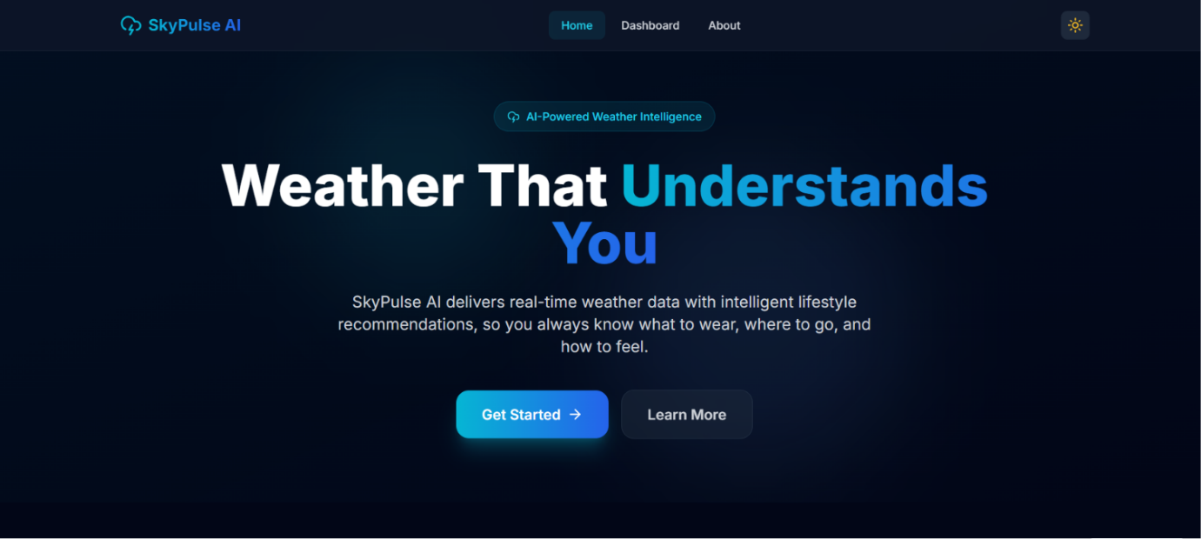

Figure 2: About Whether App
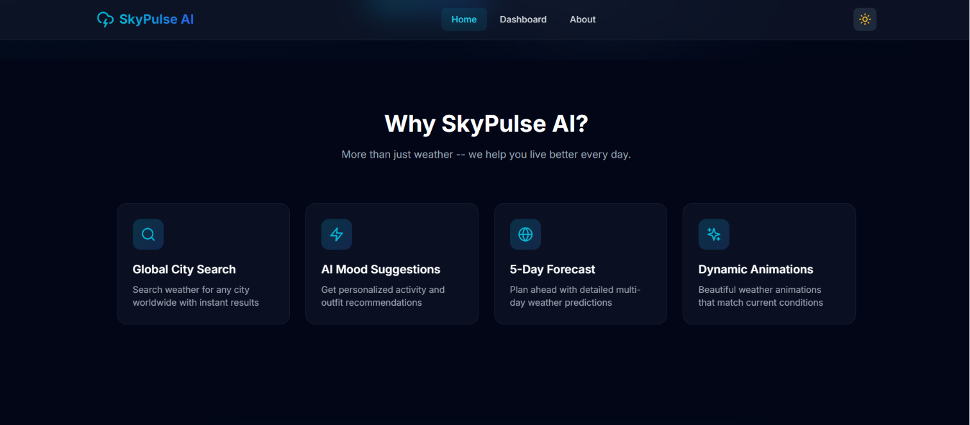

Figure 3: Information about app and API Key

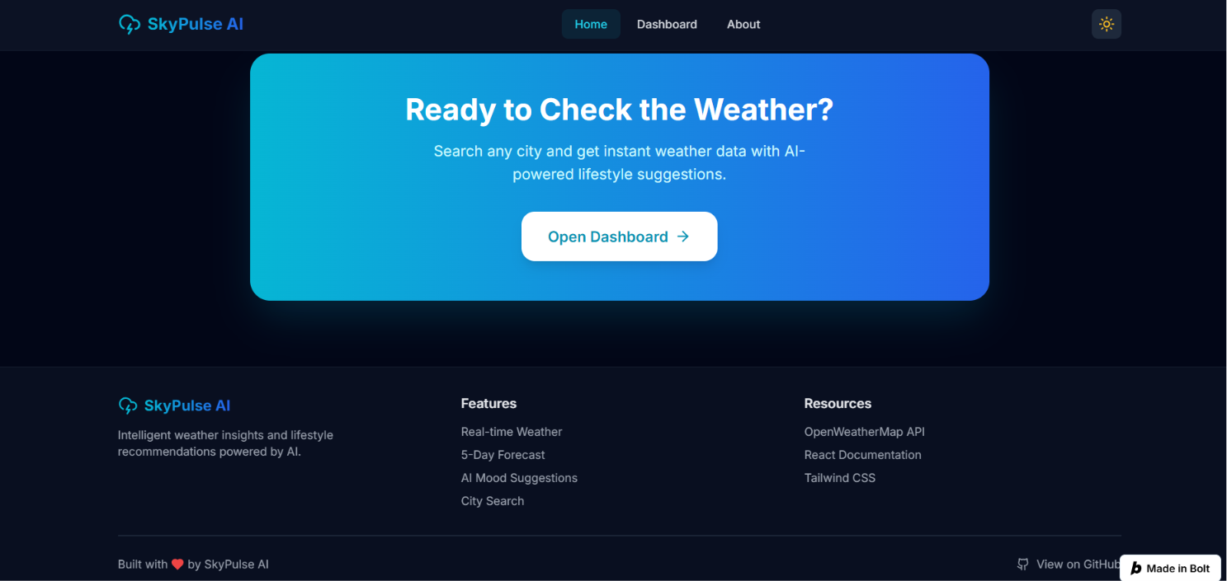

Figure 4: DashBoard

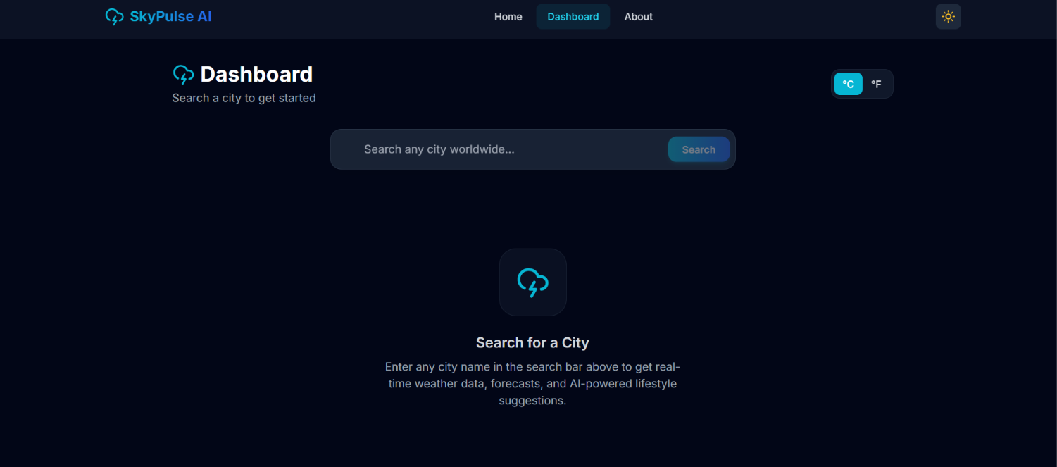

Figure 5: Results after Searching
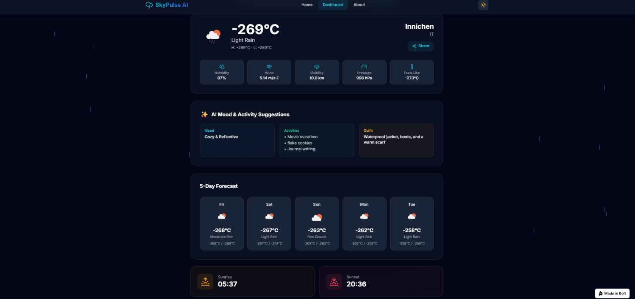

7. Code Snippets

Fetch API Example
async function getWeather(city) {
const response = await fetch(apiURL);
const data = await response.json();
displayWeather(data);
}
Description:
This function fetches weather data dynamically from the REST API using asynchronous JavaScript.

Error Handling Example
try {
const response = await fetch(url);
} catch(error) {
showErrorMessage();
}
Description:
This code handles API request failures and displays an appropriate error message to users.

8. Commands Used
npm install
npm run dev
npm run build
Deployment Command:
Project deployed using Bolt Hosting

9. Challenges Faced
One of the major challenges during development was handling asynchronous API requests efficiently while maintaining smooth UI performance. Another challenge was implementing proper loading and error states to improve user experience.
Creating a responsive layout for different screen sizes also required careful frontend design considerations.

10. Hosted Live Project
Live Website Link:
https://skypulse-ai-weather-bed9.bolt.host/

11. GitHub Repository
https://github.com/NethalaRoshitha/SkyPulseAI

12. Conclusion
This project helped in understanding REST API integration, asynchronous JavaScript programming, dynamic DOM manipulation, and responsive frontend development.
SkyPulse AI Weather successfully demonstrates how public APIs can be used to create real-world interactive web applications with modern user interfaces and improved user experience.

13. Future Improvements
- Add 7-day weather forecast
- Add geolocation support
- Implement dark/light mode
- Add weather charts and analytics
- Store recent searches using localStorage
- Add voice search functionality

